PRACTICAL 1:- Initiate the semester-long StudentHub portal by identifying the problem scope, user roles, key modules, navigation flow, and minimum 10 pages. Create a sitemap, low-fidelity wireframe, project folder structure, README file, and GitHub repository.

SITE MAP:-
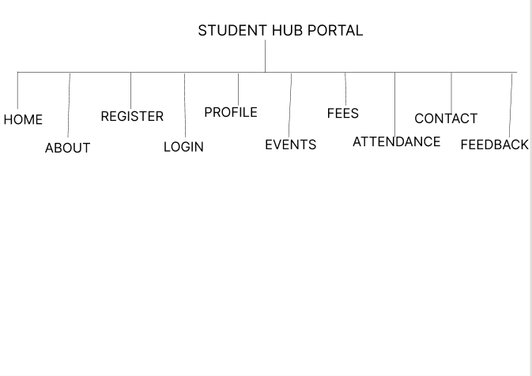

WIRE FRAME:-

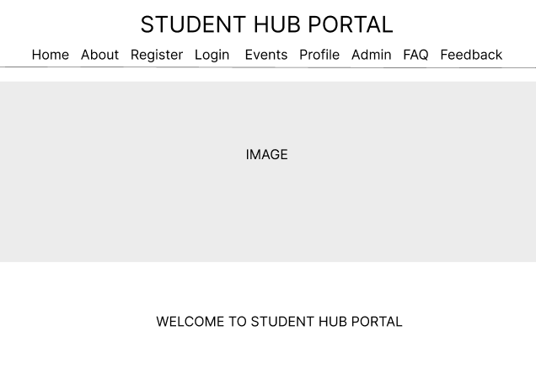

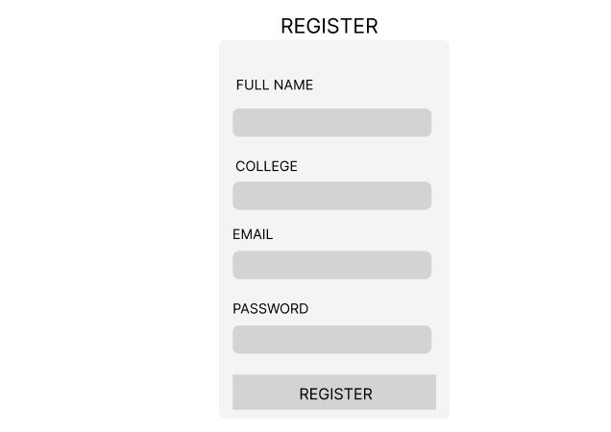
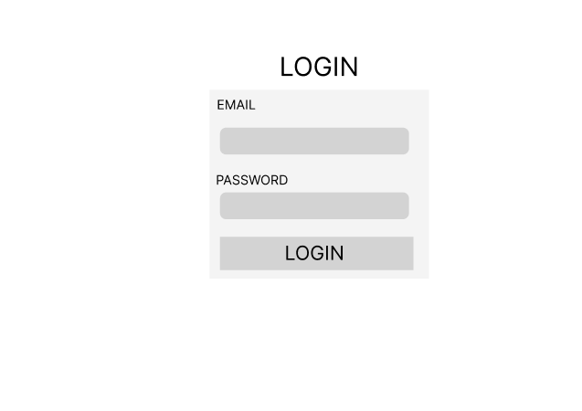

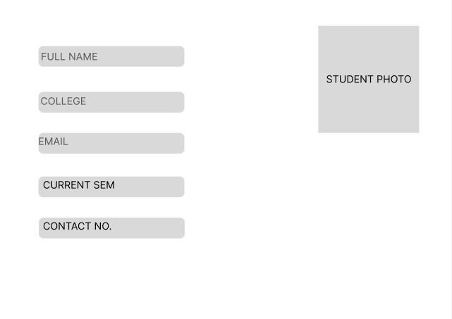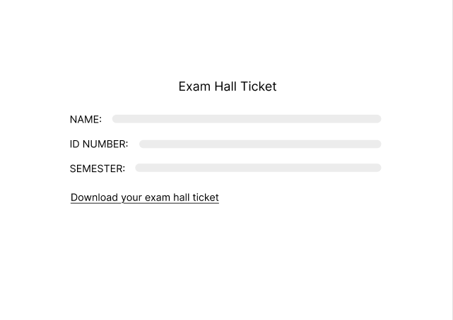
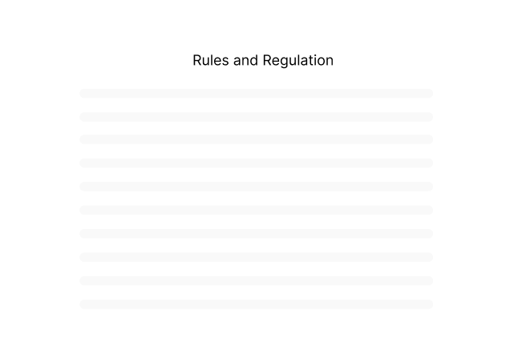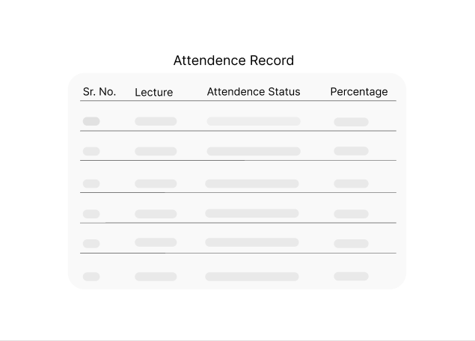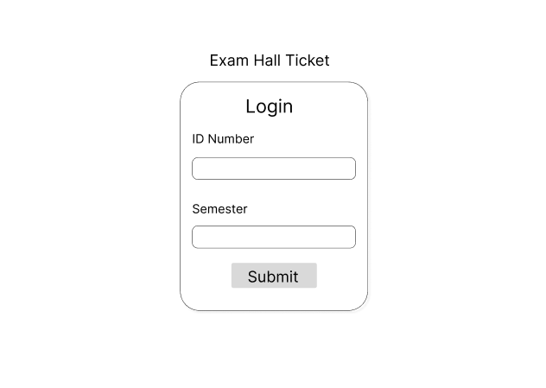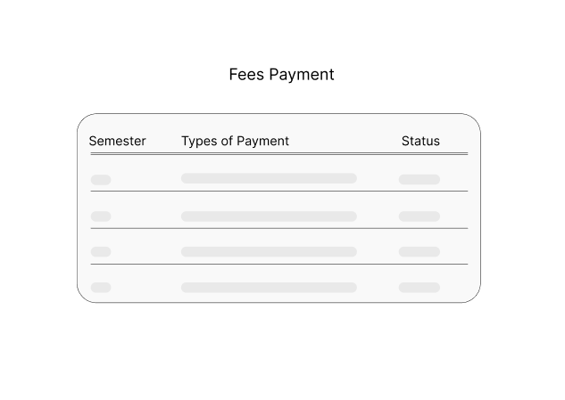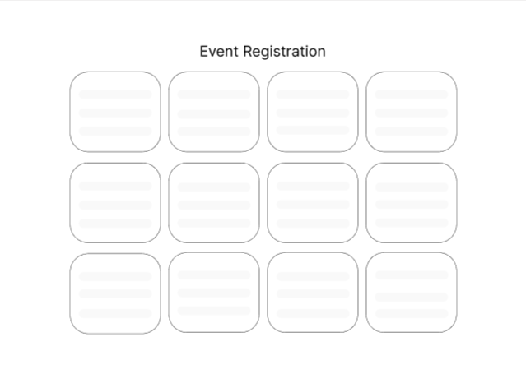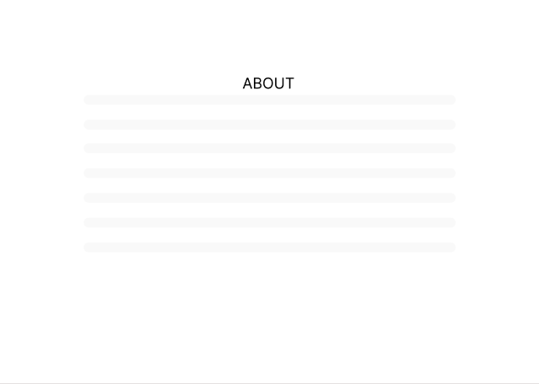
LEARNING:-
While creating the wireframe I learned that planning the website before coding makes the development process much easier. It gave me a clear idea of how all the pages would be connected and how users would navigate the website. In the beginning, my wireframe was only a rough sketch and it was not so good looking all the things were conjusted no clear gap and all so I changed the layout a few times and improved the it by adding and rearranging some pages. This practical helped me understand the importance of proper planning and organizing a website before starting development.

